Smoothing LLPAs, PMIs, and MIPs

- Introduction

We have observed a problem relating to our LLPA calculations. Currently, we assign the same LLPA for all loans whenever they fall into the same FICO/LTV bucket. The calculation of the initial spread at the CDU date between actual incentive derived from the loan level calculation and the incentive derived from the repline is very sensitive to the various CLTV thresholds and this impact persists for all future cash flows. For example, for the single repline case, this was a problem for N13.80(AS) where the CLTV was 80:0% in the 2017-11 CDU for the pool-level calculation and 79:9% for the loan-level. One way to avoid this problem is if all our CLTV thresholds are consistent with those of the LLPA grid. Right now we create a bucket for 80 ~ 90% CLTV so that a potential problem can take place if CLTV is around 85% as there are some differences in LLPAs around that threshold. Another possibility is to smooth out the LLPA matrix so that there are no jumps around the threshold.

We prefer to smooth out the LLPA matrix using bilinear interpolation. For each FICO/CLTV cell, we'll assume that the LLPA value corresponds to the center of the cell. These centers essentially define a new grid with function values (LLPAs) corresponding to the corners of the grid. Now, given an (FICO, CLTV) value, we place the value in the appropriate grid using a lookup and then use bilinear interpolation to estimate the LLPA of this value.

- Bilinear Interpolation

Bilinear interpolation is an extension of linear interpolation for interpolating functions of two variables (e.g., x and y) on a rectilinear 2D grid. The key idea is to perform linear interpolation first in one direction, and then again in the other direction. Although each step is linear in the sampled values and in the position, the interpolation as a whole is not linear but rather quadratic in the sample location.

Suppose that we want to find the value of the unknown function f at the point (x; y). It is assumed that we know the value of f at the four points Q₁₁ = (x₁, y₁), Q₁₂ = (x₁, y₂), Q₂₁ = (x₂, y₁), and Q₂₂ = (x₂, y₂). We first do linear interpolation in the x-direction. This yields:
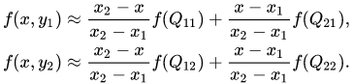

A similar idea allows us to find f(x, y₂) and thus complete interpolation in the x-direction.
We proceed by interpolating in the y-direction to find:
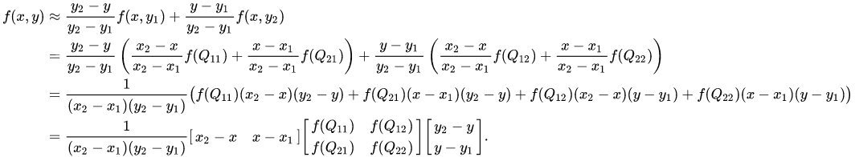
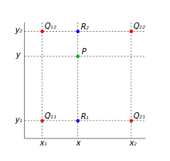
The four red dots show the data points and the green dot is the point at which we want to interpolate.
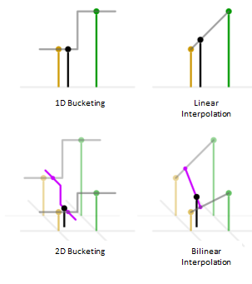
By changing the bucketing method to bilinear method, we will expect the value changing more smoothly when switching from one bucket to another.

* More information can be found on the Wikipedia page: https://en.wikipedia.org/wiki/Bilinear_interpolation

- Implementing The Smoothing Algorithm

- Bucket Matrix to Point Matrix

The raw information we get from the agency is a bucket-based underwriting matrix with each bucket (or cell) corresponding to a range of CLTV and FICO values (see the table below). In order to apply the bilinear interpolation, we first have to transform this bucket based matrix to a point-based one.
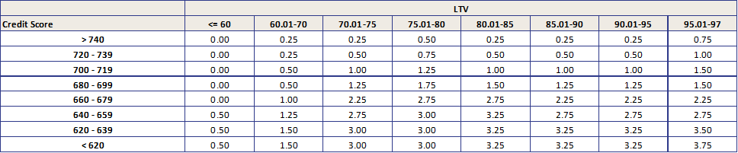

To make the transformation unbiased, we will assign the LLPA value of the bucket to the midpoint of the CLTV and FICO.
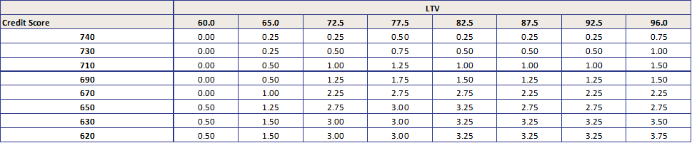

For each given loan, we need to figure out the four nearest points: LTV_{low}, LTV_{high}, FICO_{low}, FICO_{high}. And the four corresponding LLPA value. As the sybase IQ database is not a multiple dimension DB, there is no easy way to know the “nearest” points using the table directly. So we have to go one step more, to create a table that database/C++ calculation can directly refer to.

The table would need to have all the possible combinations of “nearest points” and their corresponding four LLPA values. Plus the information of the matrix’s start date and expiry date, the LLPA matrix table that can be used in our calculation will look like:
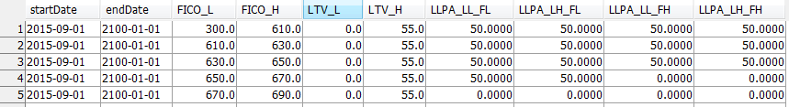

The database table works

- Handling the Out-of-boundary Cases

The point based table in step 1 only defined the LTV range from 60 to 96 and FICO range from 620 to 740. Although it is a known fact the out-of-boundary high LTV or low FICO loans are not eligible to refinance, we need to make appropriate assumptions for the “unrestricted” incentive calculation despite the eligibility.

After discussion with PM, the following assumptions are made to the calculation:
 | Direction | Assumed Coordinate | Assumed LLPA
FICO | Lower End | Nearest value -10 | Max LLPA of the same LTV Column
 | Higher End | Nearest value+10 | Same as the nearest value
LTV | Lower End | Nearest value - 2.5 | Same as the nearest value
 | Higher End | Nearest value | Max LLPA of the same FICO Raw

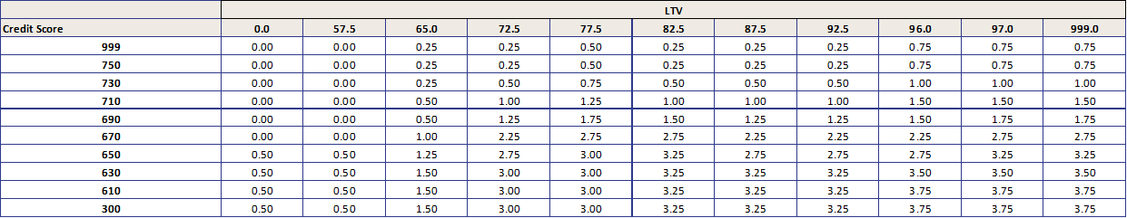
Notice that the current LLPA assumption for those two cases are “max LLPA of the matrix”, in the September 2015 version, that means 3.75%. The highest FICO group with 740 or more would now being assigned 0.75% LLPA when it’s LTV is higher than 97. This is a 300 bps difference for CQ/CR incentive calculation.

- Apply Different Interpolation Methods to Sub-tables

In the previous section, the LLPA base table is transformed to a point based coordinator matrix prepared for the bilinear interpolation. We can apply the algorithm discussed in II to each given loan/pool based on the new matrix.

However, the LLPA base table is just one piece of the puzzle. To get the full picture, we need to also apply the transformation and interpolation to occupancy, unit number, and loan size, as well as the tables for PMI and MIP. Those tables have different dependencies on variety of directions, that need to be handled separately.

The table below is a short summary of how different interpolation methods would be applied to the required matrices:
 | Matrix | Interpolation Method | Directions
LLPA | Base | Bilinear | LTV, FICO
 | Occupancy | Linear | LTV
 | Units | Linear | LTV
 | Loan Size | Linear | Loan Size
PMI | Base | Bilinear | LTV, FICO
 | Occupancy | Bilinear | LTV, FICO
 | Loan Size | Bilinear + Linear | LTV, FICO then Loan Size
MIP | Base | Bilinear | LTV, Loan Size

- Impact on Historical Incentive Calculation

The new LLPA/PMI/MIP matrices together with the interpolation smoothing algorithm, provides a new series of incentive. The most noticeable changes for the historical incentive will be:
- The loans with high LTV, such as CQ/CR loans, will have much lower LLPA/PMI/MIP numbers. That will result as high incentive. The differences in due to the update of assumptions for the out-of-boundary cases mentioned in III.2.
- The loans with low FICO will also have lower LLPA/PMI. MIP won’t be affected.
- For a single loan, with the CLTV and loan size changing, the incentive will change more gradually. The LLPA/PMI/MIP decrease will change from the step function to a linear function.

With the origPMI, origMIP, currentLLPA, currentPMI, and currentMIP updates, the incentive will be recalculated. And the burnout number will also be recalculated as a new version. The updates will be applied to:
 | Database | Data Field
FNM | LL and PL | Incentive and Burnout
FHL | LL and PL | Incentive and Burnout
GNM | LL | Incentive and Burnout

- Update Incentive Projection

The incentive projection in Scale will apply the same interpolation algorithm as mentioned. But as the necessary input, we need to translate the database table III.1 to a JSON file that C++ can process correctly. After the bilinear and linear interpolation mentioned in III.3, we will have a smoothed projection for LLPA/PMI/MIP and incentive, burnout.

Here is an example for the N14.1(KS) bond projection:
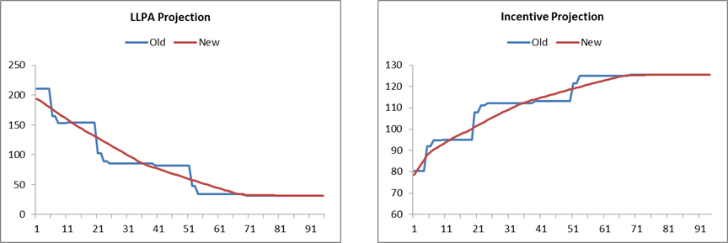
* LLPA projection is the sum of projection values for LLPA base, occupancy, unit and loan size.

- Process Automation

From the discussion III.1 to III.5, we can see there is a LLPA matrix transformation path from the raw bucket-based table to a point-based table, then to a database “nearest points” table, and then to a JSON file for C++ projection. Each of those steps require careful handling that we want to avoid human intervention as much as we can.

We have introduced an automatic process to handle the table transformation steps. So when the LLPA/PMI/MIP underwriting standards get updated, we don’t need to take the risk of bring in human error. When the agencies release a new version of those matrices, we will only need to input the raw table to database, and the process will take care of the rest.

Appendix - Related Table Names in Database:

- LLPA:
- Smoothed Tables:
  - report.Cello_LLPA_Base_Bilinear_Interpolation
  - report.Cello_LLPA_Occupancy_Linear_Interpolation
  - report.Cello_LLPA_Units_Linear_Interpolation
  - report.Cello_LLPA_LoanSize_Interpolation
- Raw Tables:
  - report.Cello_LLPA_Base_Raw
  - report.Cello_LLPA_Occupancy_Raw
  - report.Cello_LLPA_Units_Raw
  - report.Cello_LLPA_LoanSize_Raw

- PMI:
- Smoothed Tables:
  - report.Cello_PMI_Base_Bilinear_Interpolation
  - report.Cello_PMI_Occupancy_Bilinear_Interpolation
  - report.Cello_PMI_LoanSize_Bilinear_Interpolation
- Raw Tables:
  - report.Cello_PMI_Base_Raw
  - report.Cello_PMI_Occupancy_Raw
  - report.Cello_PMI_LoanSize_Raw

- MIP:
- Smoothed Tables:
  - report.Cello_MIP_Base_Bilinear_Interpolation
- Raw Tables:
  - report.Cello_MIP_Base_Raw

